CS543 Assignment 2

**Your Name: Hanliang**

**Your NetId:  hj33**

Part 1 Fourier-based Alignment:

You will provide the following for each of the six low-resolution and three high-resolution images:

* Final aligned output image
* Displacements for color channels
* Inverse Fourier transform output visualization for ***both*** channel alignments ***without*** preprocessing
* Inverse Fourier transform output visualization for ***both*** channel alignments ***with*** any sharpening or filter-based preprocessing you applied to color channels

You will provide the following as further discussion overall:

* Discussion of any preprocessing you used on the color channels to improve alignment and how it changed the outputs
* Measurement of Fourier-based alignment runtime for high-resolution images (you can use the python time module again). How does the runtime of the Fourier-based alignment compare to the basic and multiscale alignment you used in Assignment 1?

A: Channel Offsets

Replace <C1>, <C2>, <C3> appropriately with B, G, R depending on which you use as the base channel. Provide offsets in the **original image coordinates** (after the image has been divided into three equal parts corresponding to each channel) and be sure to account for any cropping or resizing you performed.

Low-resolution images (using channel R as base channel):

|  |  |  |
| --- | --- | --- |
| Image | G (h,w) offset | B (h,w) offset |
| 00125v.jpg | (5,0) | (10,1) |
| 00149v.jpg | (4,2) | (9,2) |
| 00153v.jpg | (15,2) | (11,4) |
| 00351v.jpg | (4,0) | (13,1) |
| 00398v.jpg | (5,2) | (11,4) |
| 01112v.jpg | (0,0) | (5,1) |

High-resolution images (using channel <C1> as base channel):

|  |  |  |
| --- | --- | --- |
| Image | <C2> (h,w) offset | <C3> (h,w) offset |
| 01047u.tif | (26,3) | (51,7) |
| 01657u.tif | (57,5) | (122,14) |
| 01861a.tif | (71,24) | (147,62) |

B: Output Visualizations

For each image, insert 5 outputs total (aligned image + 4 inverse Fourier transform visualizations) as described above. When you insert these outputs be sure to clearly label the inverse Fourier transform visualizations (e.g. “G to B alignment without preprocessing”).

00125v.jpg

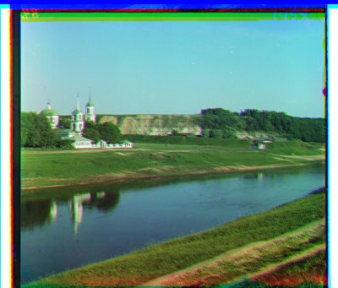

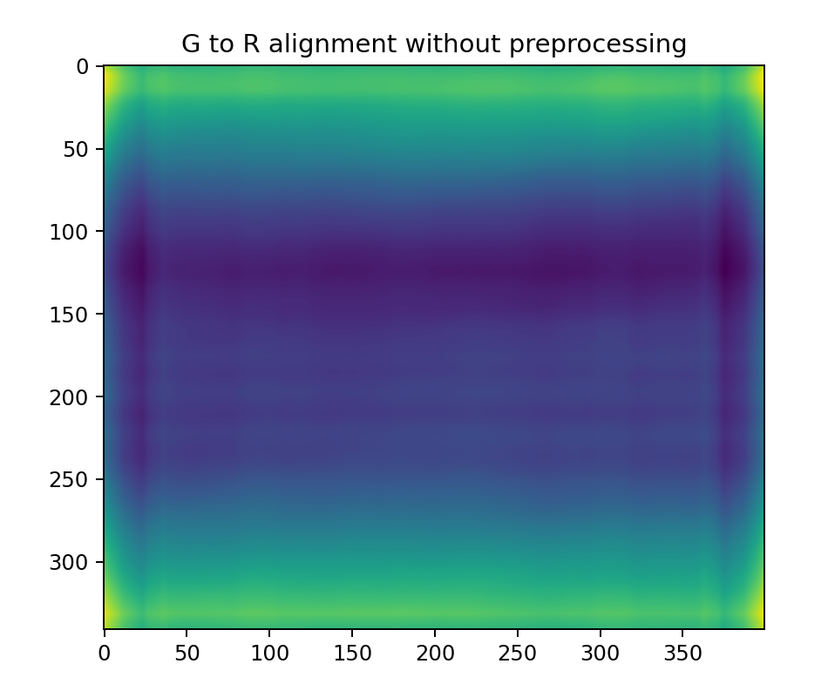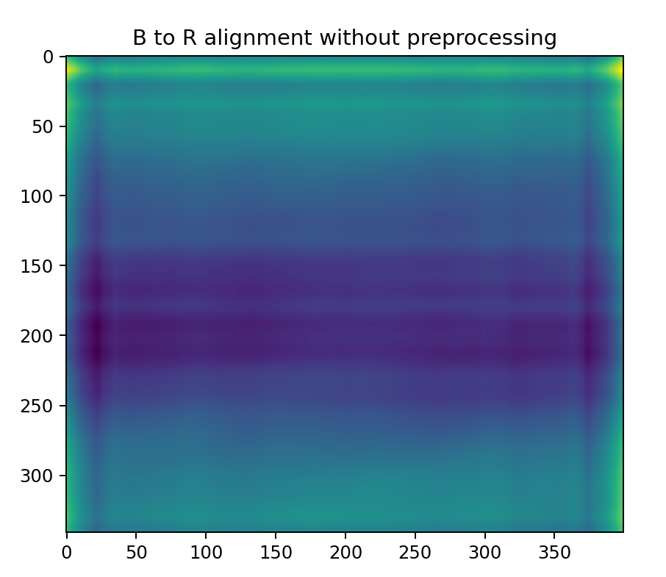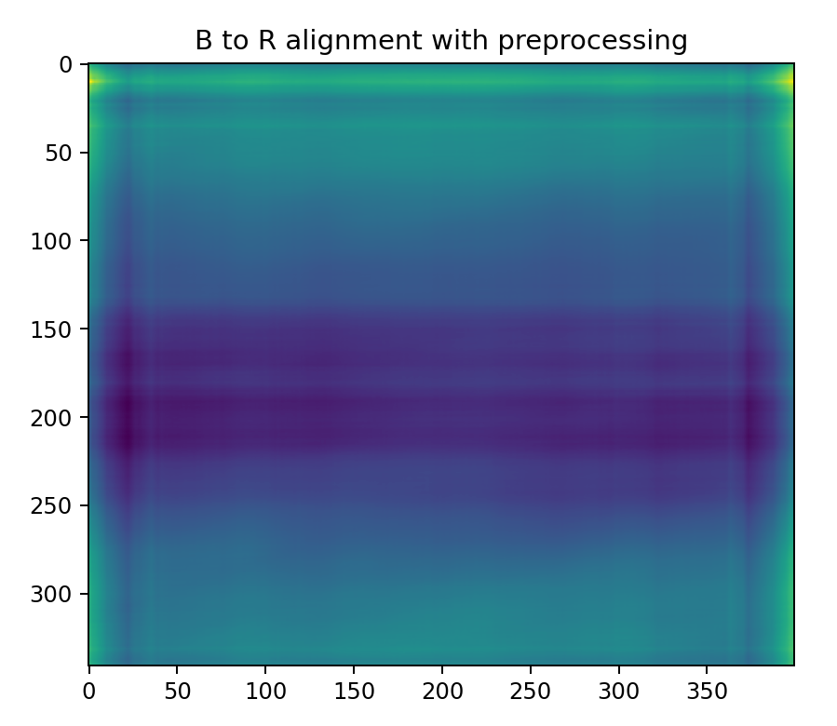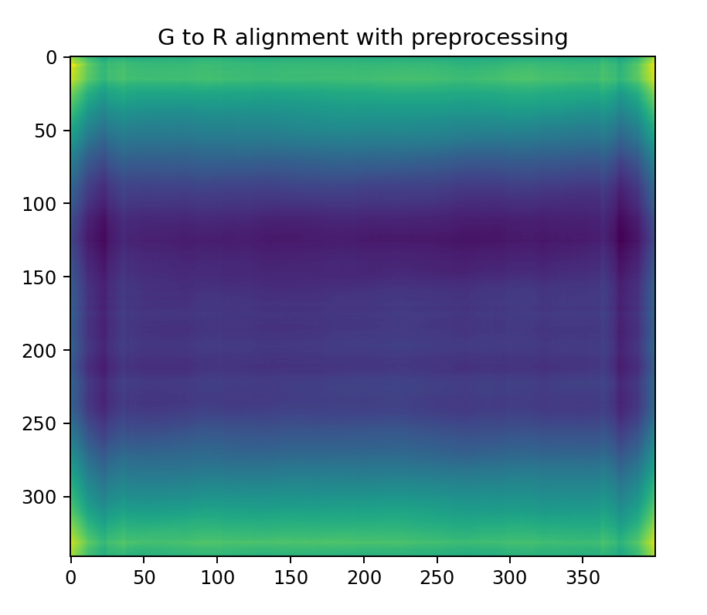00149v.jpg

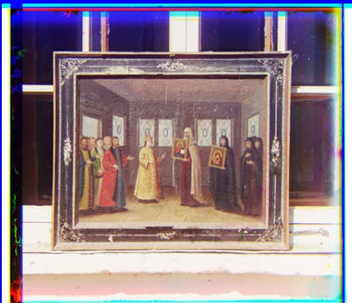

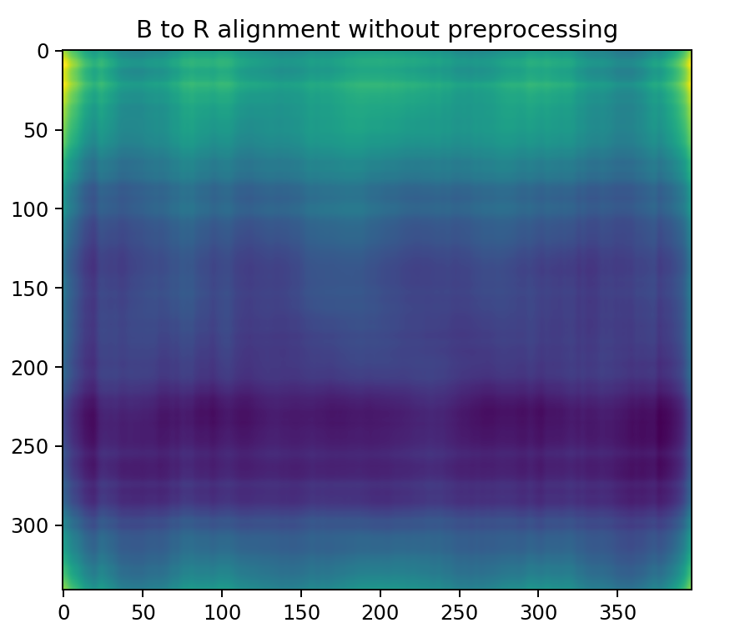 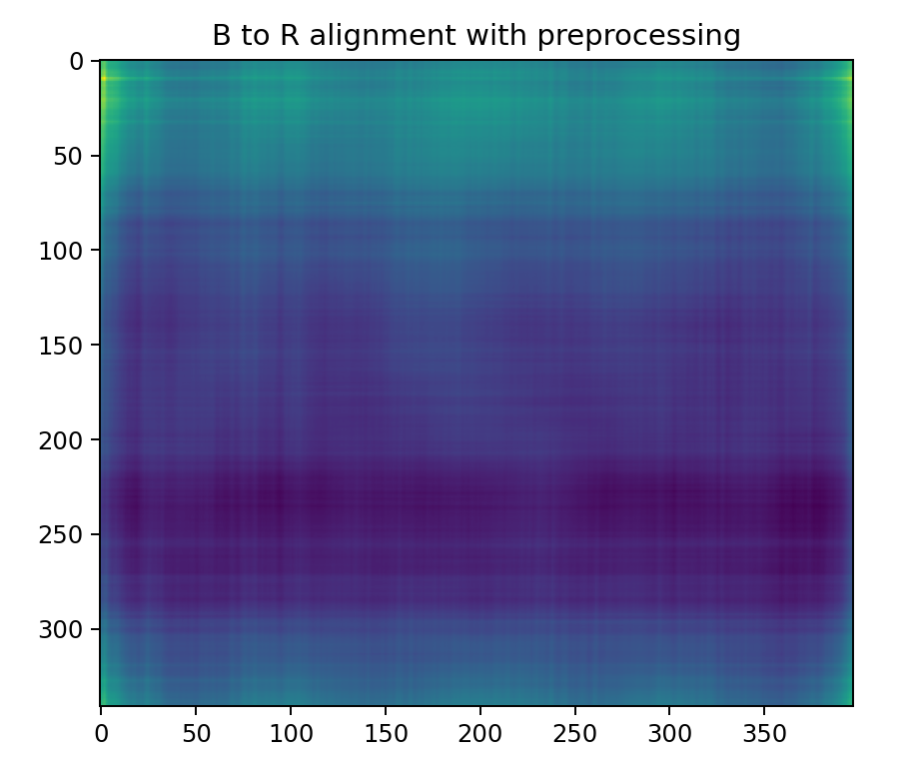 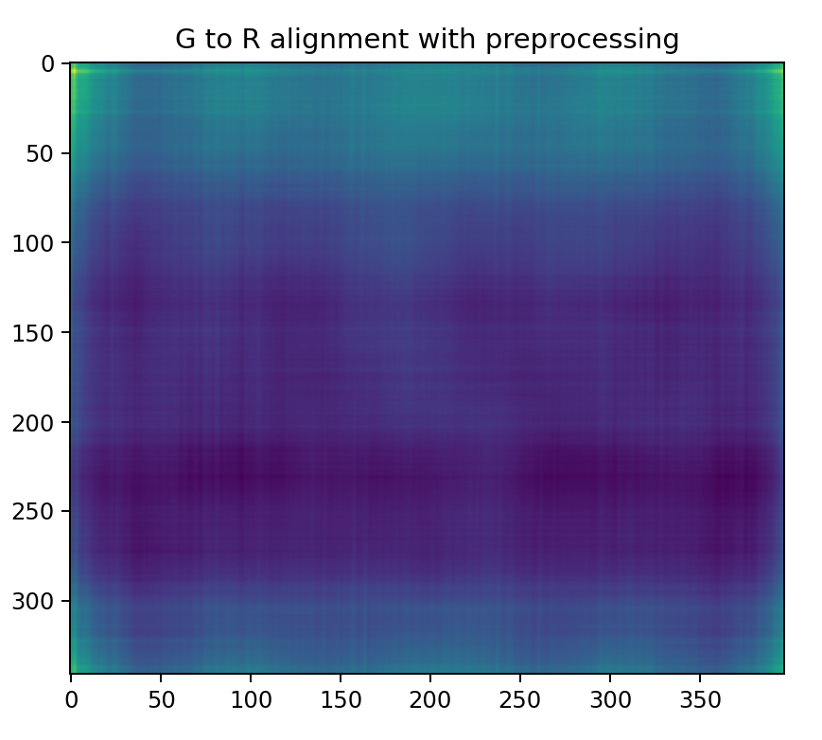 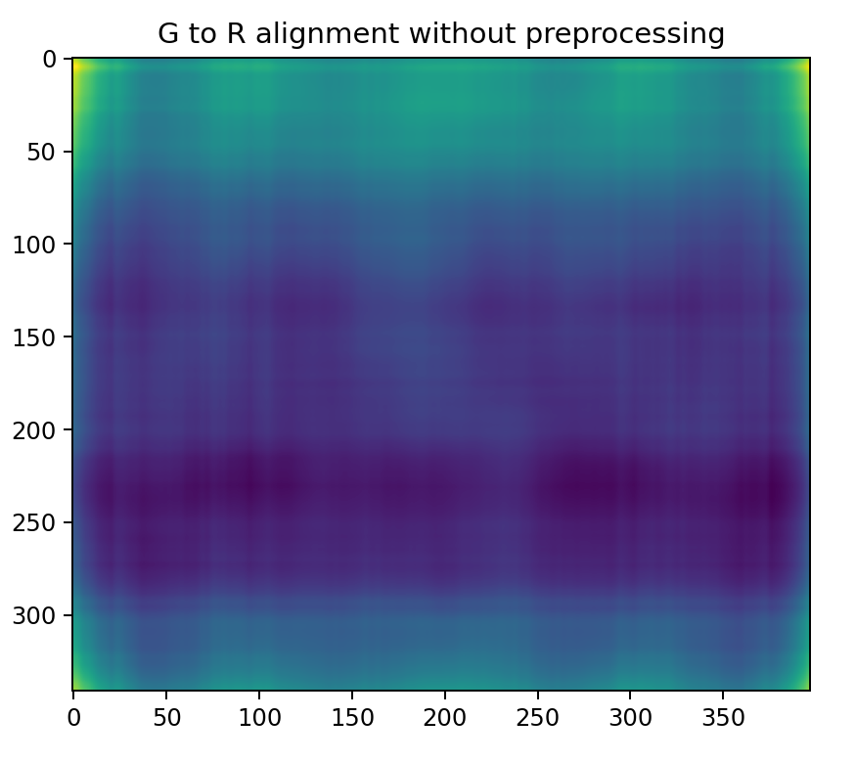

00153v.jpg

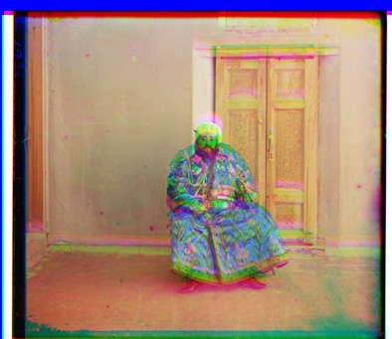

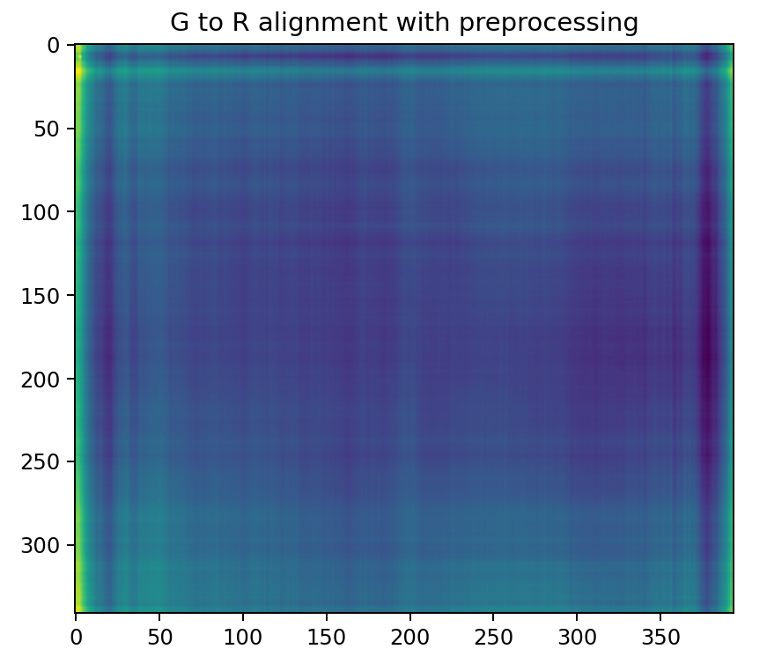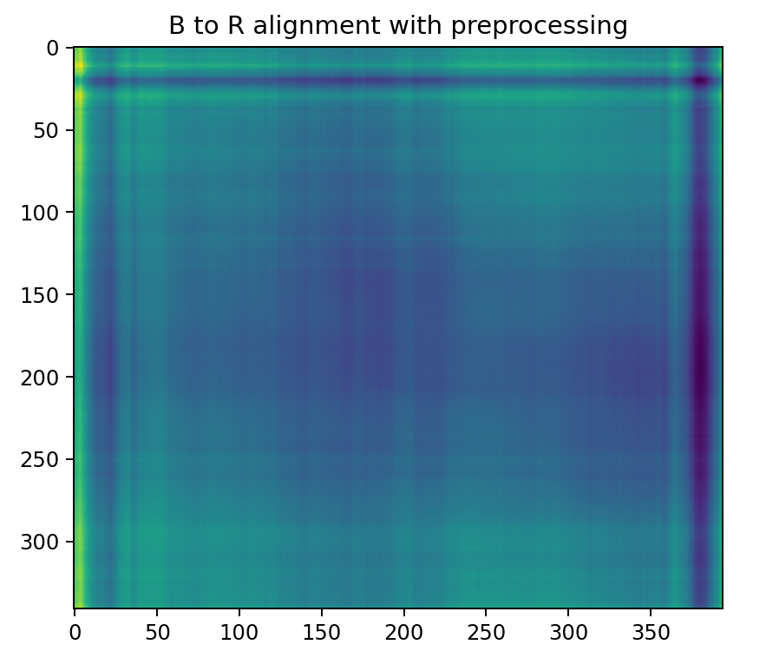

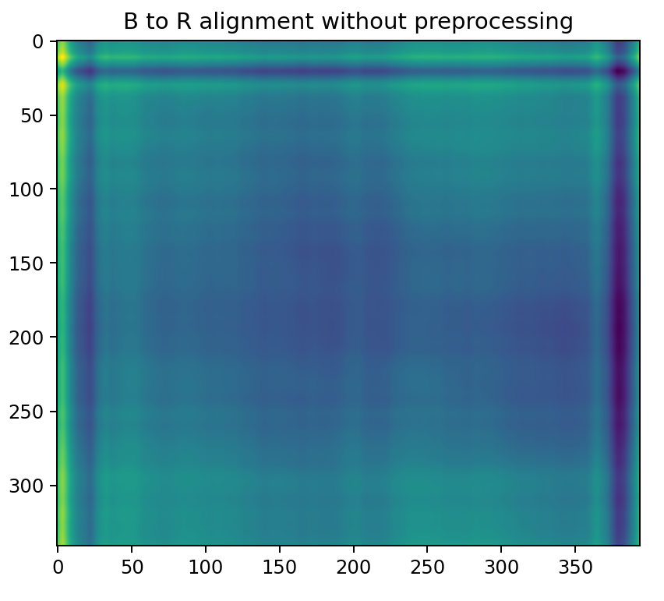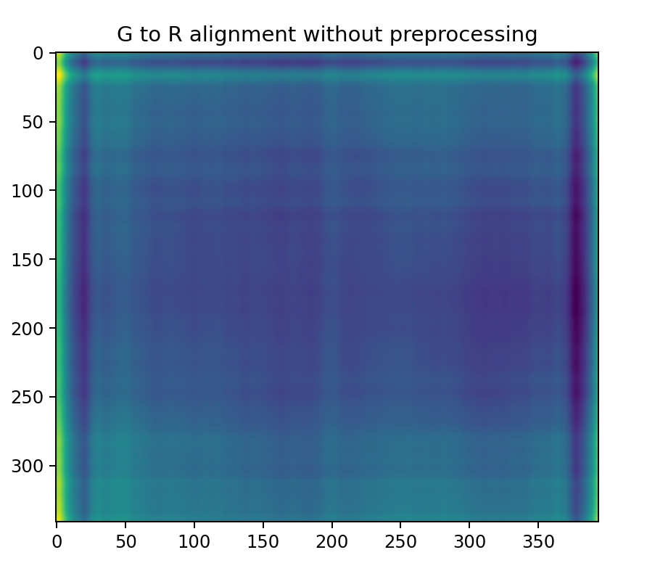

00351v.jpg

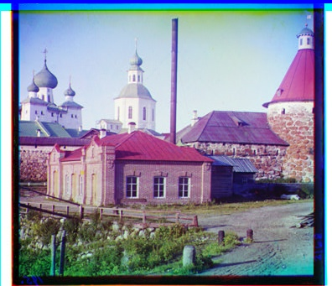

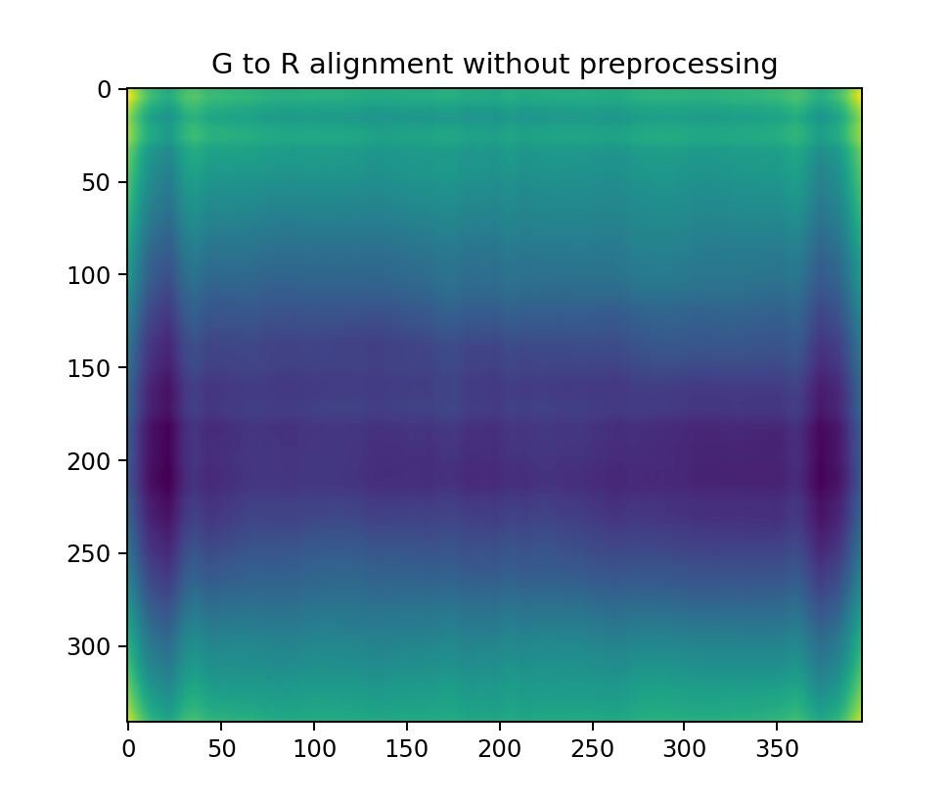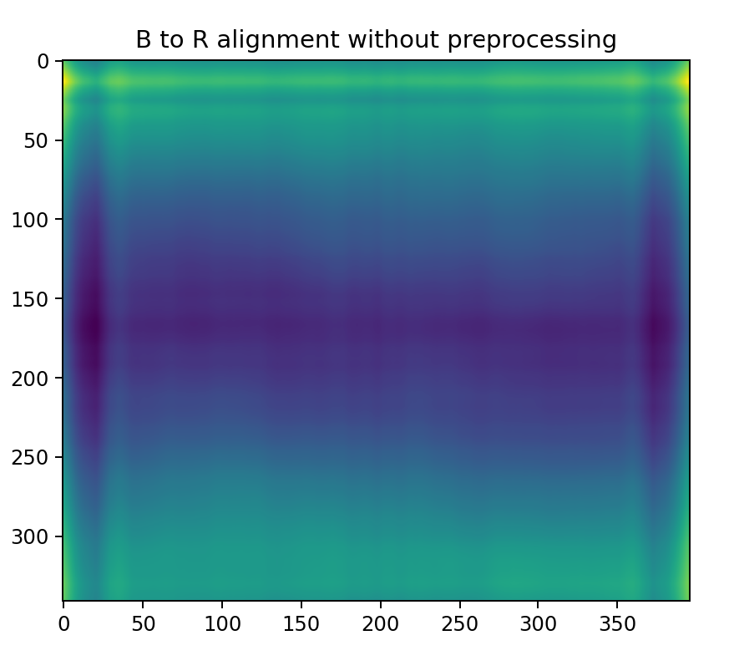

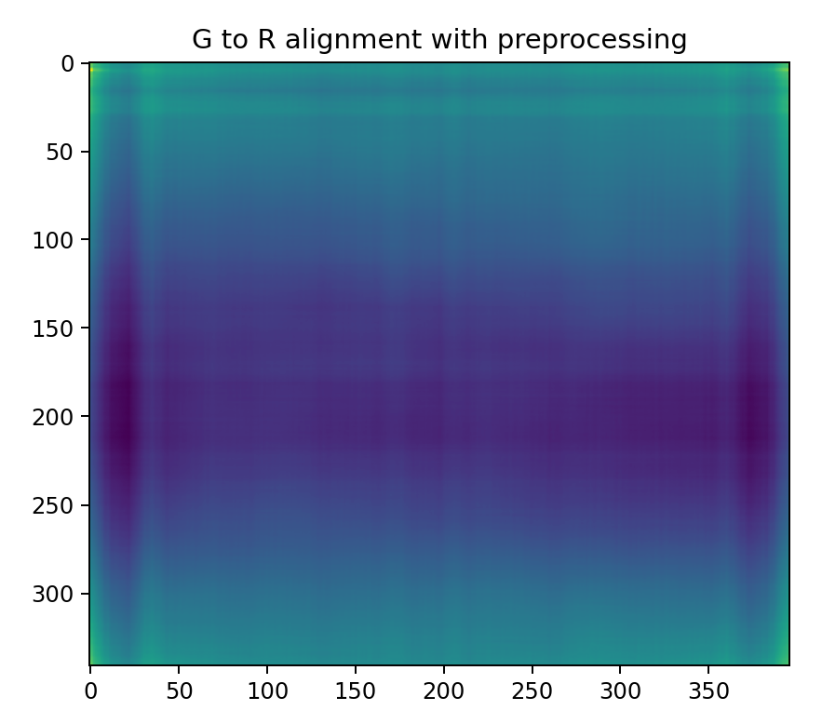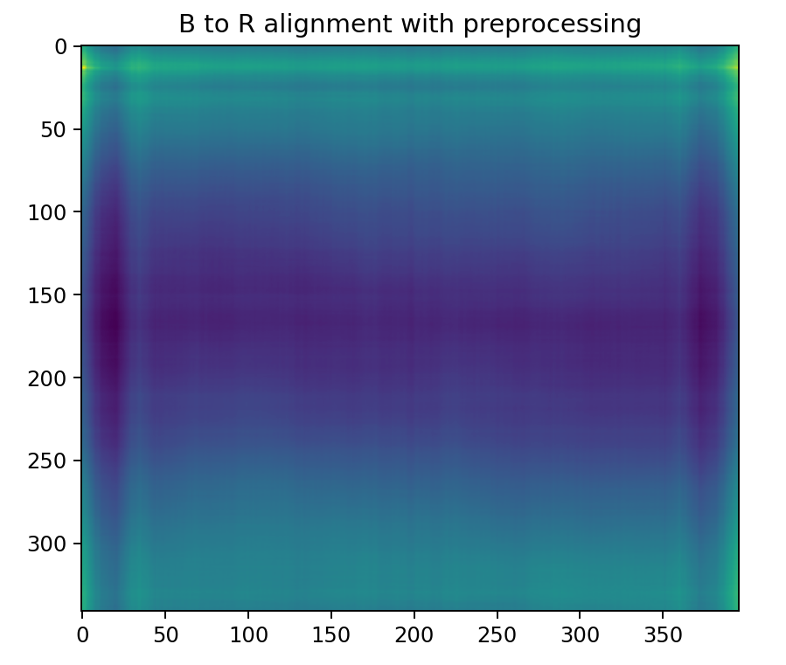

00398v.jpg

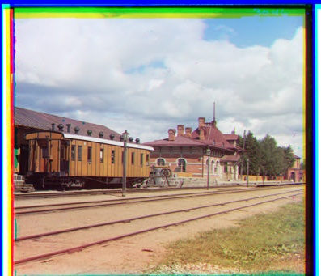

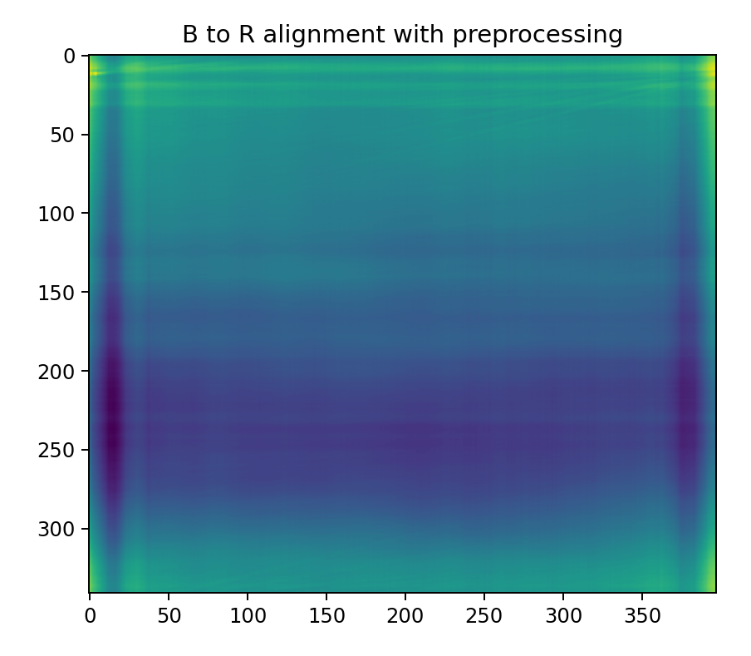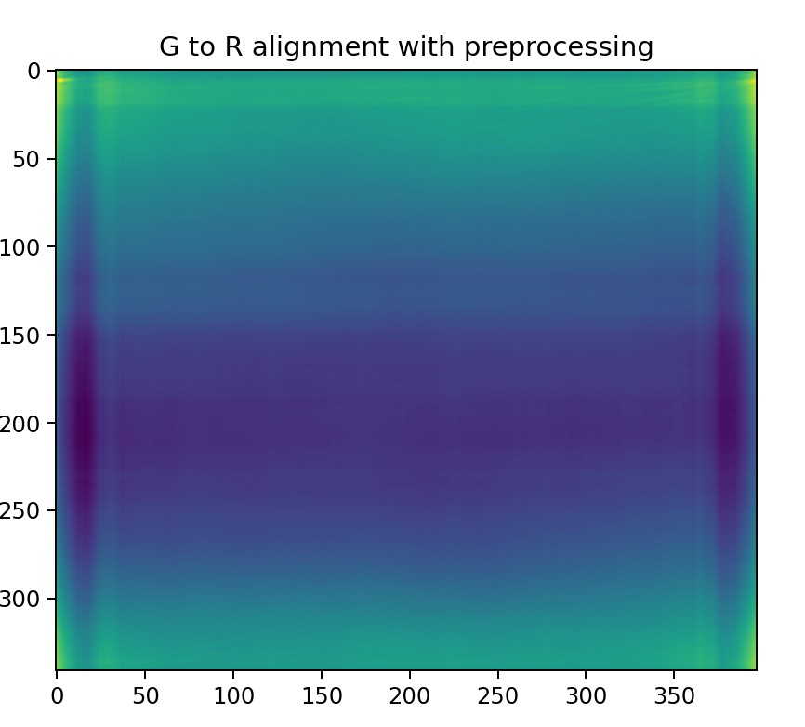

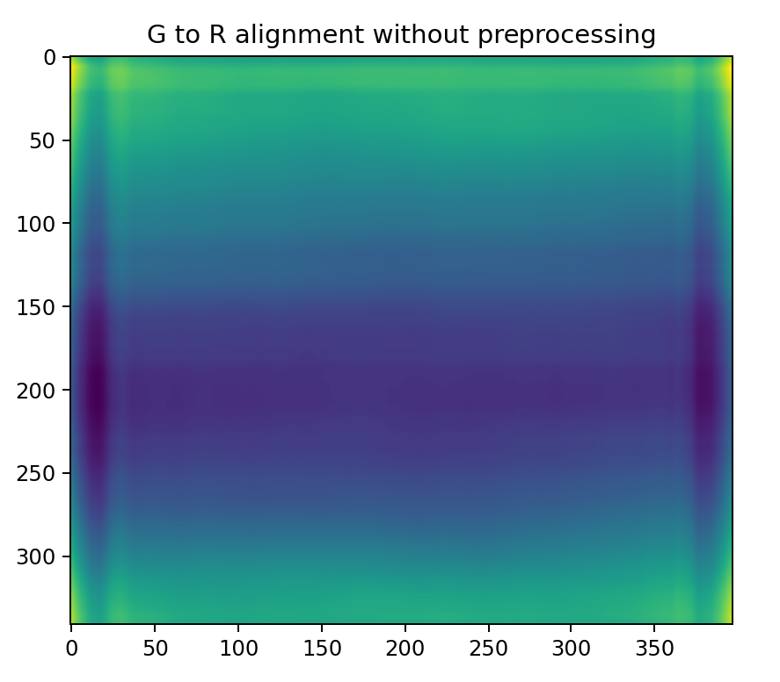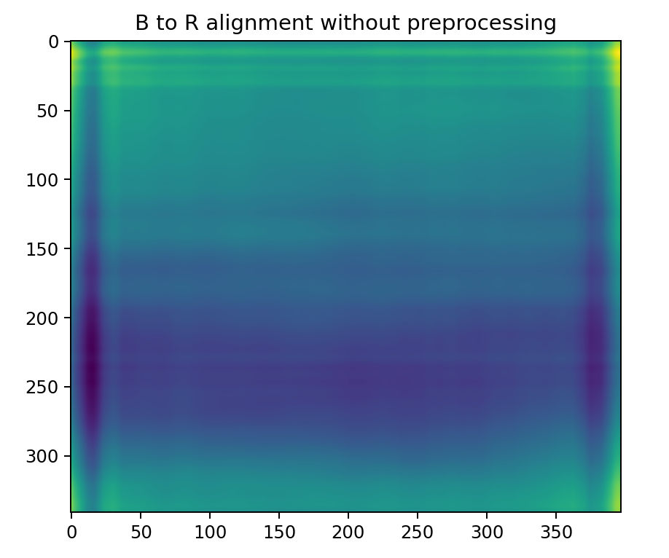

01112v.jpg

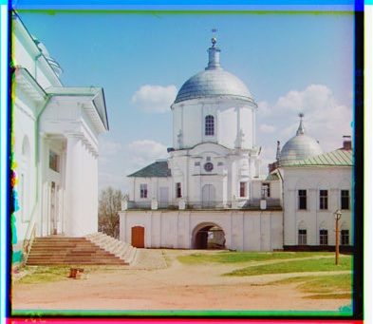

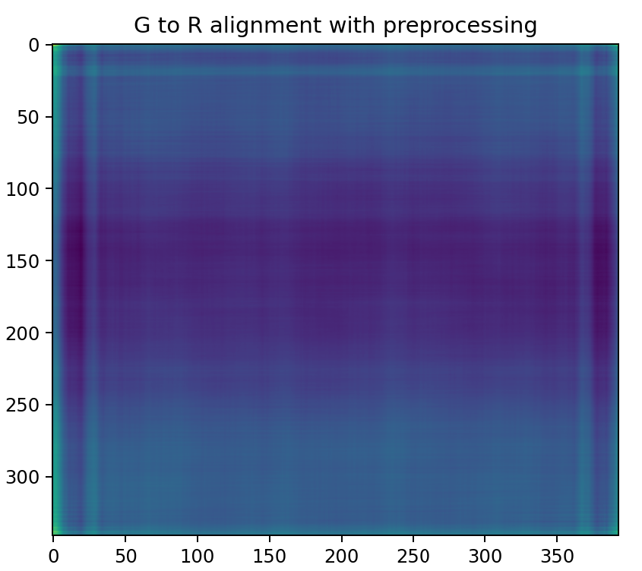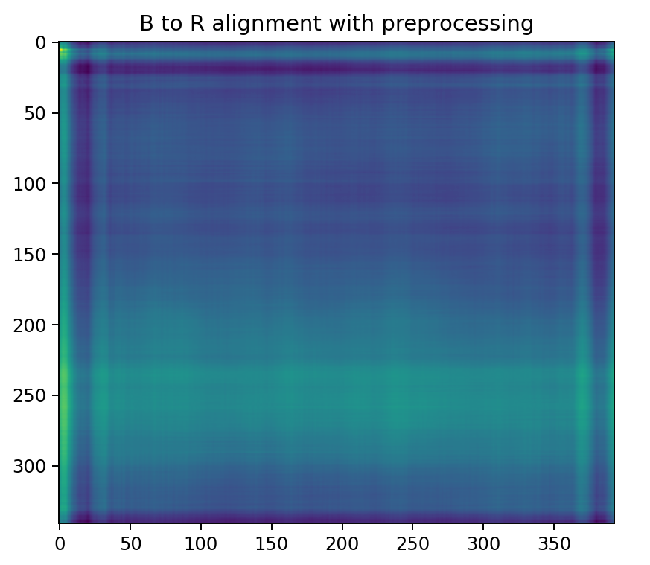

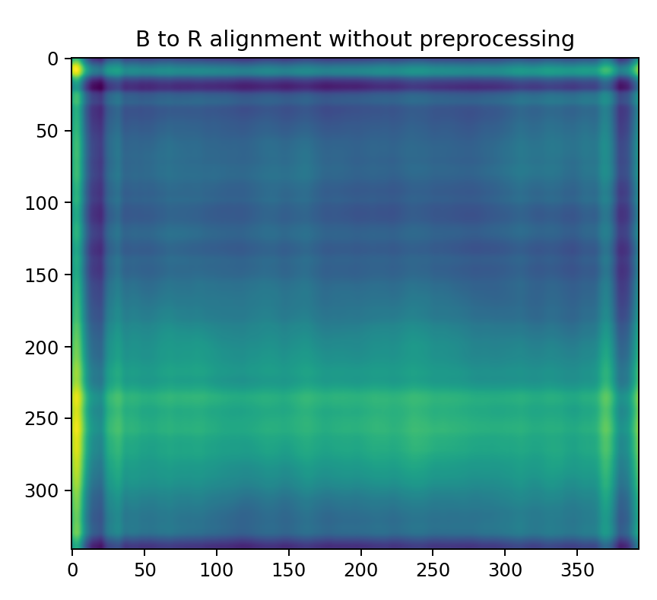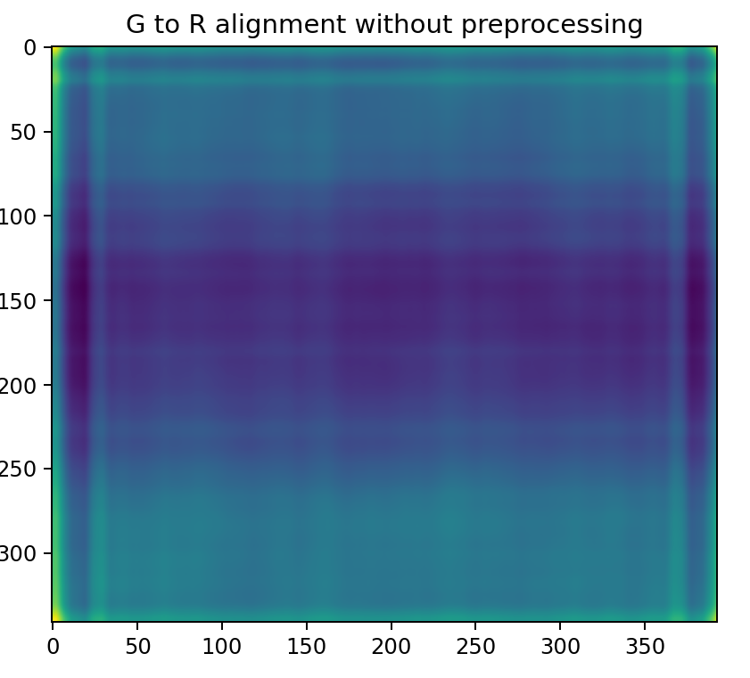

01047u.tif

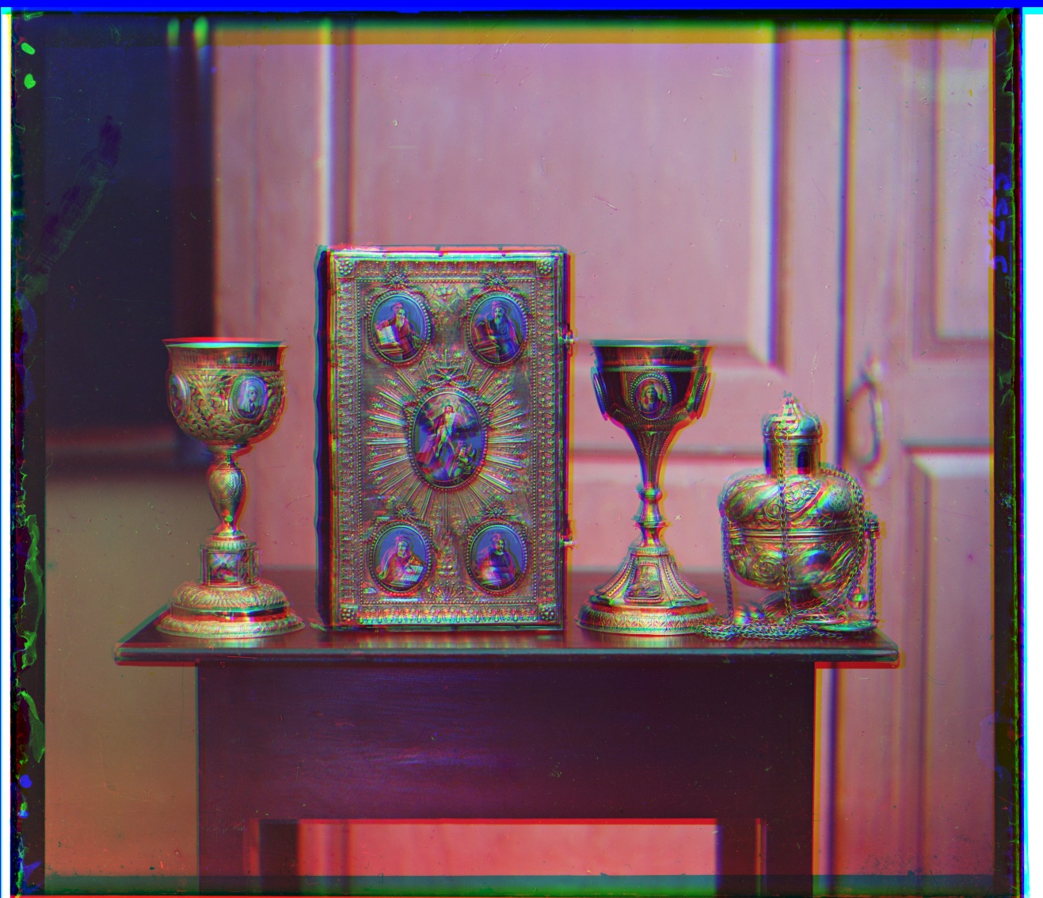

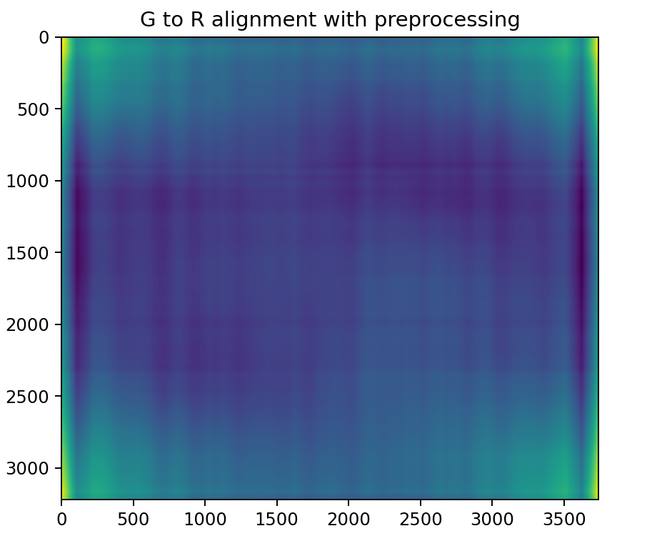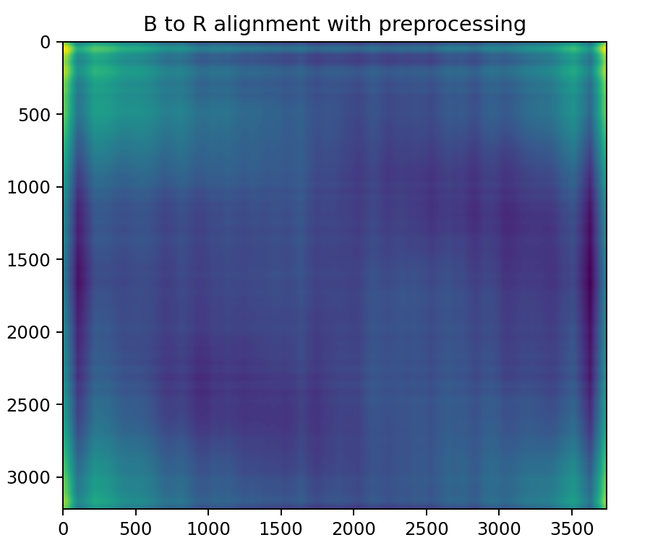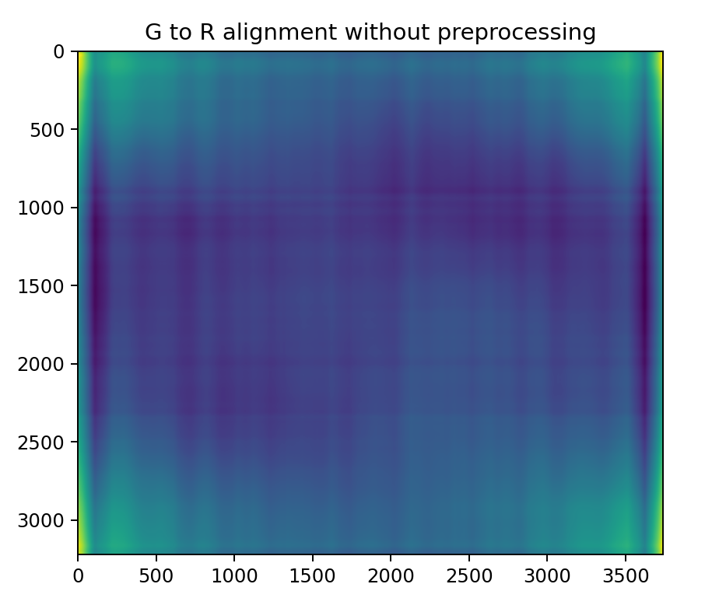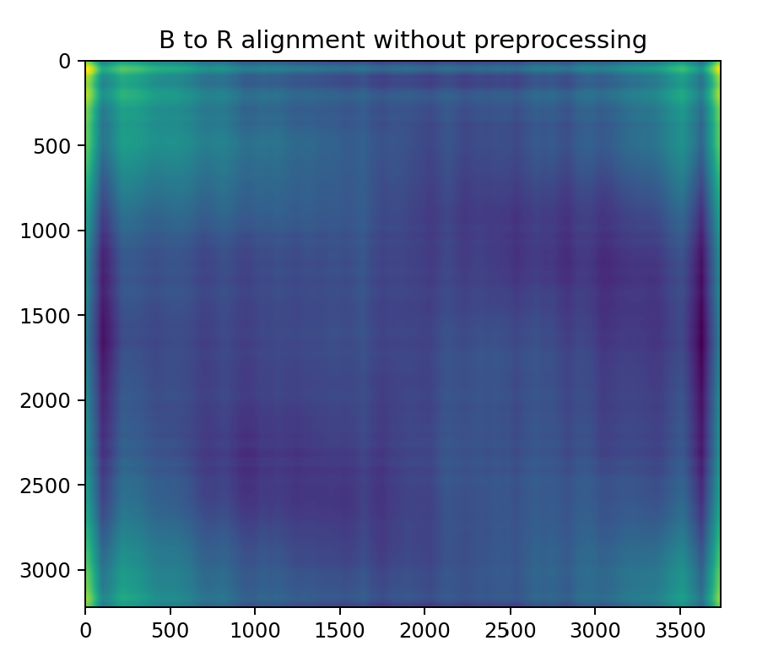

01657u.tif

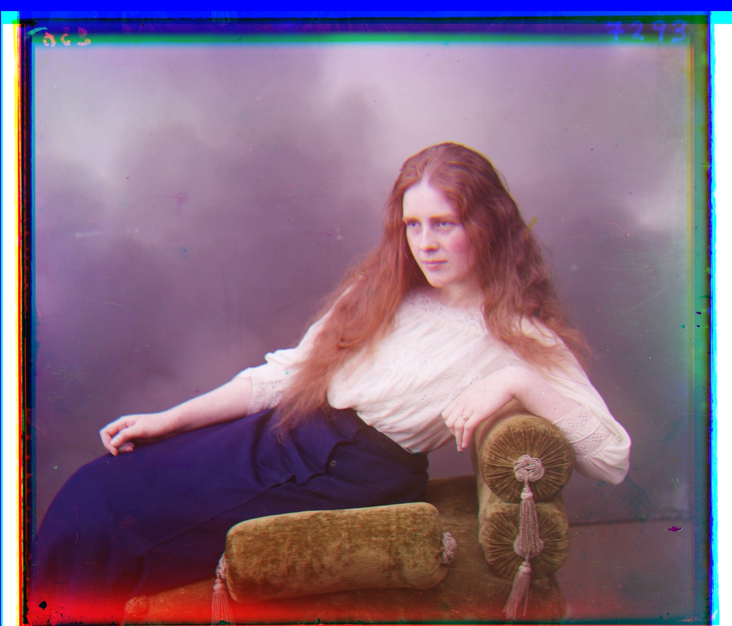

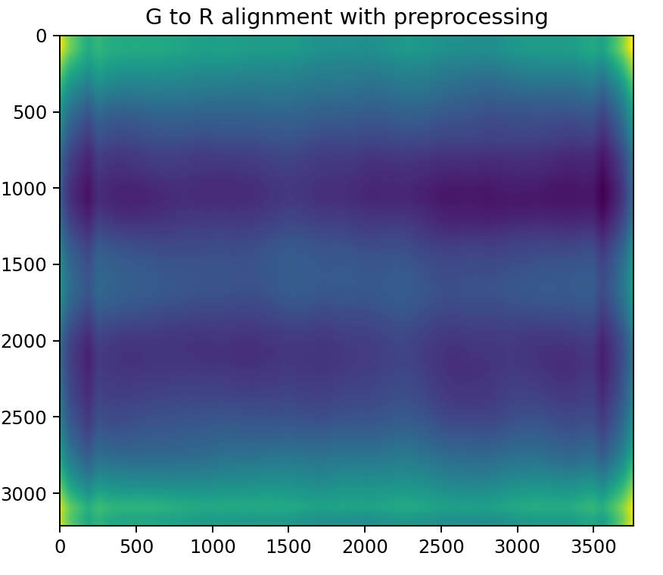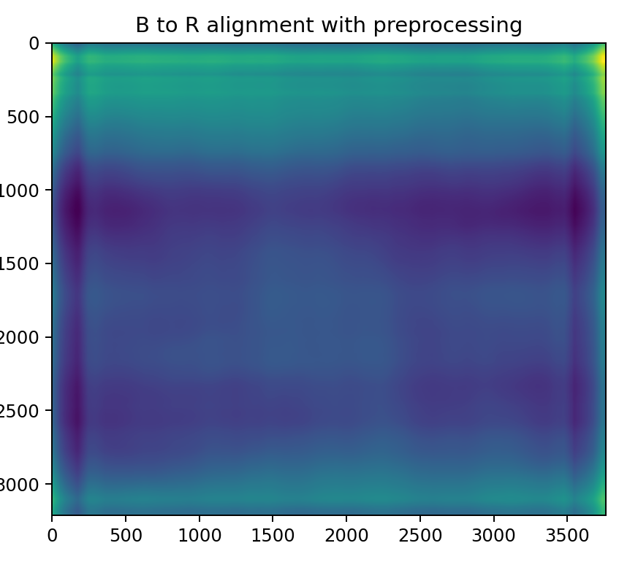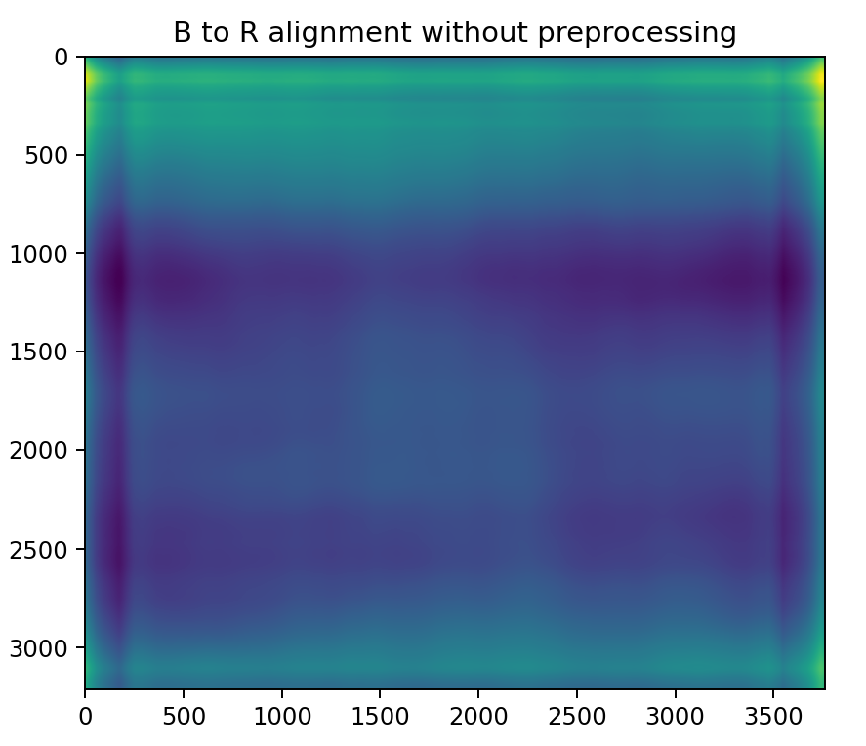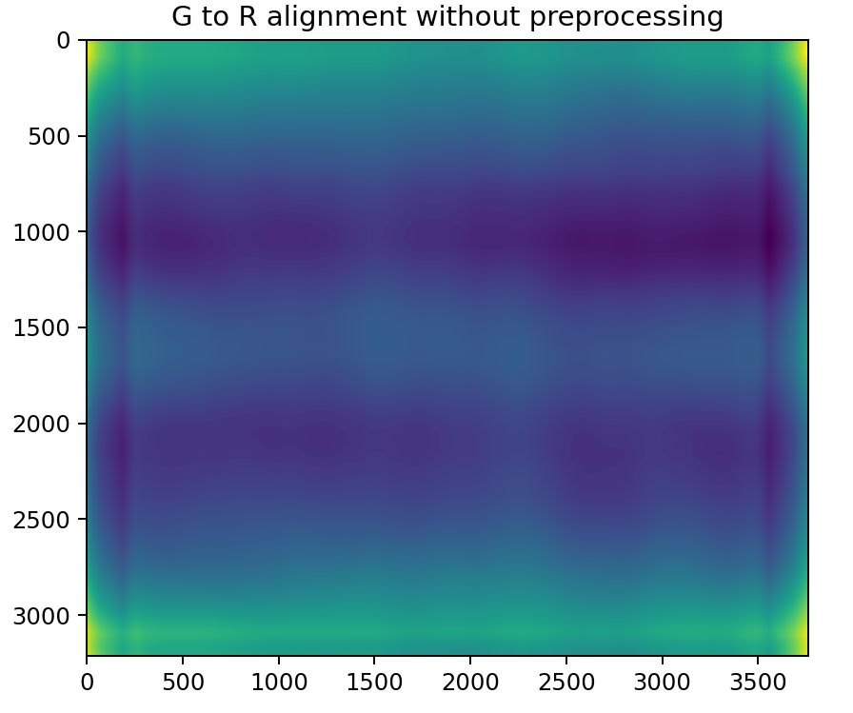

01861a.tif

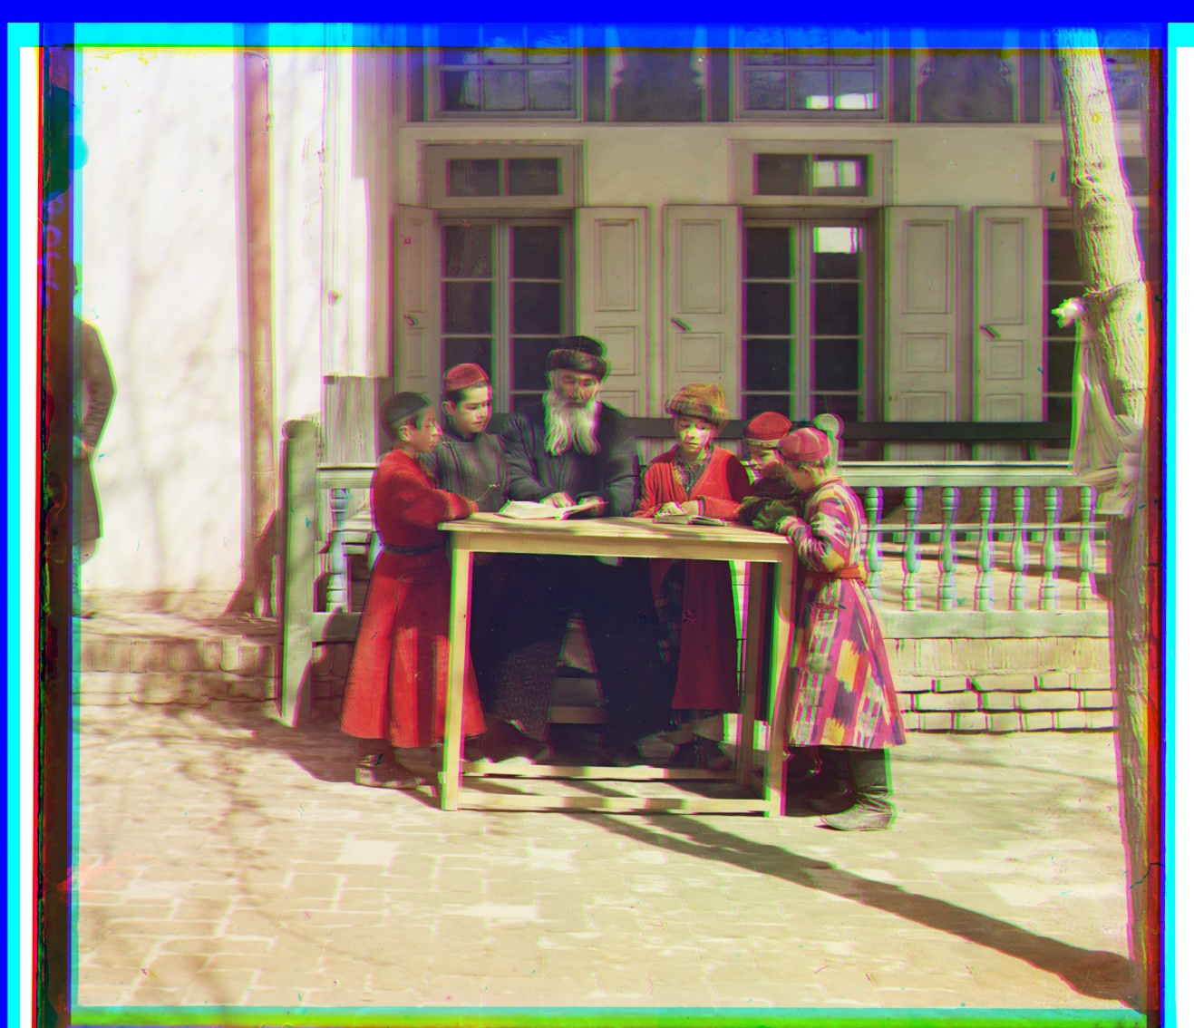

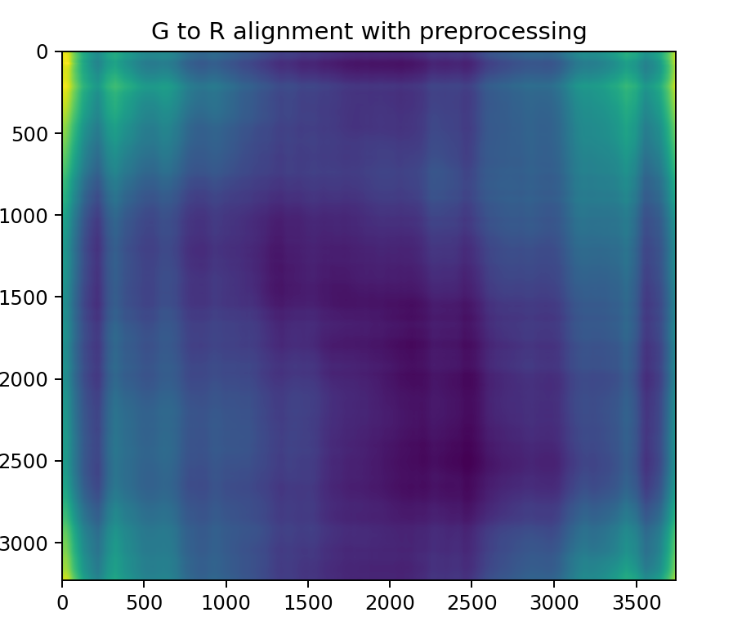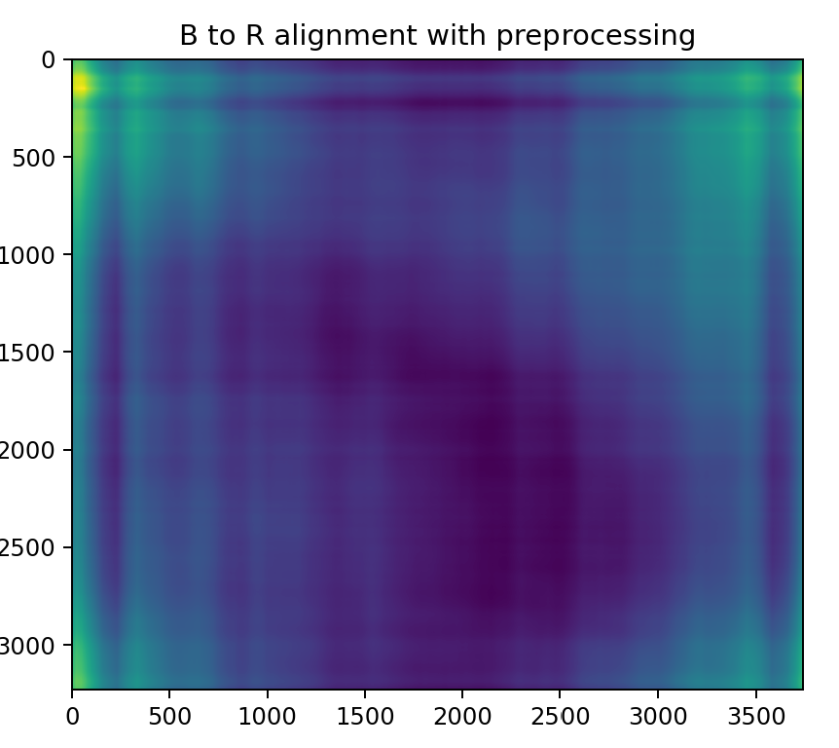

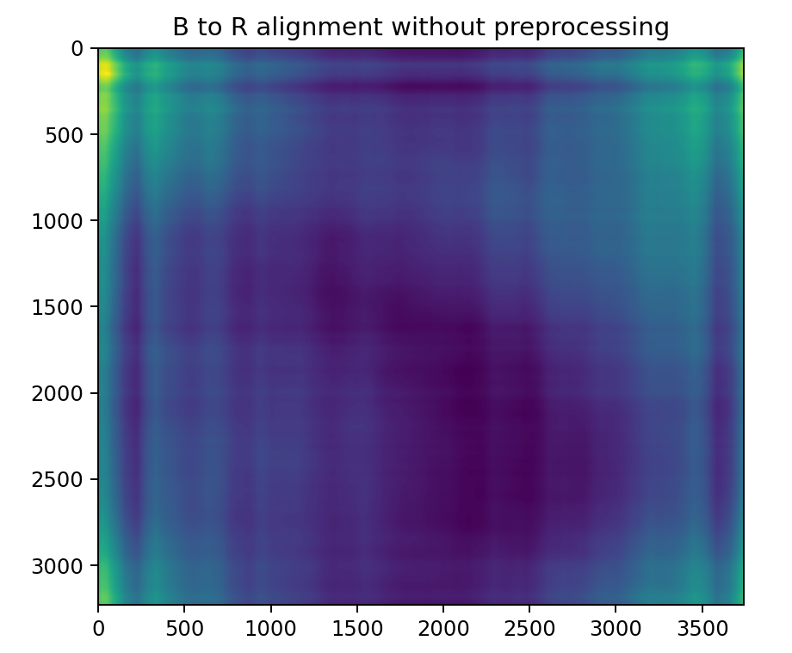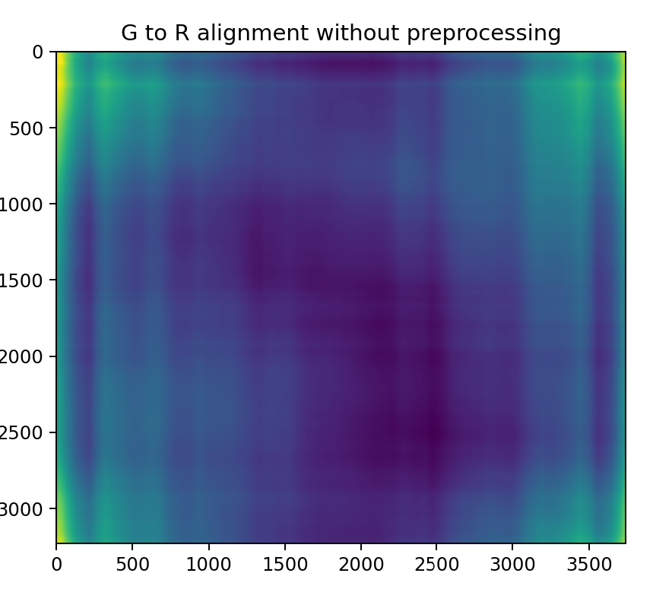

C: Discussion and Runtime Comparison

I used sharpening method by writing a kernel to sharp the image as preprocessing. Comparing the offset given by image with preprocessing and one without preprocessing, to be honest, the two offsets have very little discrepancy, so do the output images.

Comparing the runtime of both low resolution and high resolution images, for lower resolution, the runtime doesn’t improve much after I change algorithm from NCC to FFT. However, the runtime for higher resolution improve from 10000 seconds on average to 30 seconds on average with FFT. So to recap, the FFT improves runtime of higher resolution images significantly.

Part 2 Scale-Space Blob Detection:

You will provide the following for ***8 different examples***(4 provided, 4 of your own):

●  original image

●  output of your circle detector on the image

●  running time for the "efficient" implementation on this image

●  running time for the "inefficient" implementation on this image

You will provide the following as further discussion overall:

●  Explanation of any "interesting" implementation choices that you made.

●  Discussion of optimal parameter values or ones you have tried

Example 1:

runtime：29.019416332244873

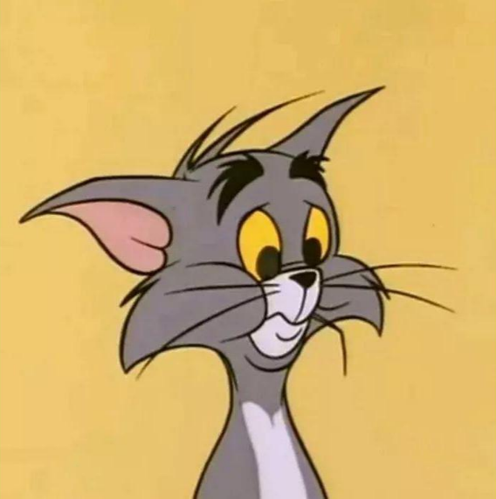

original image

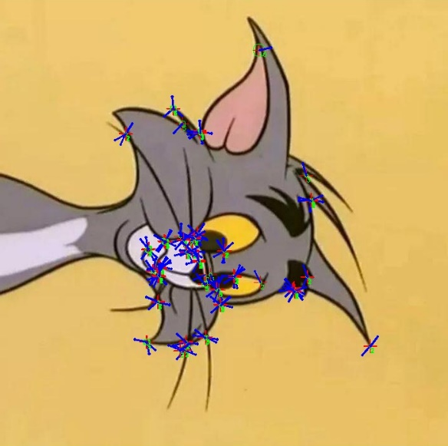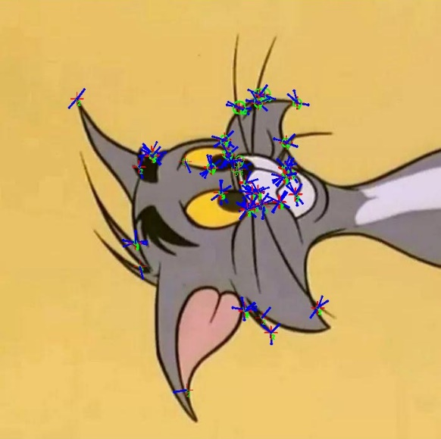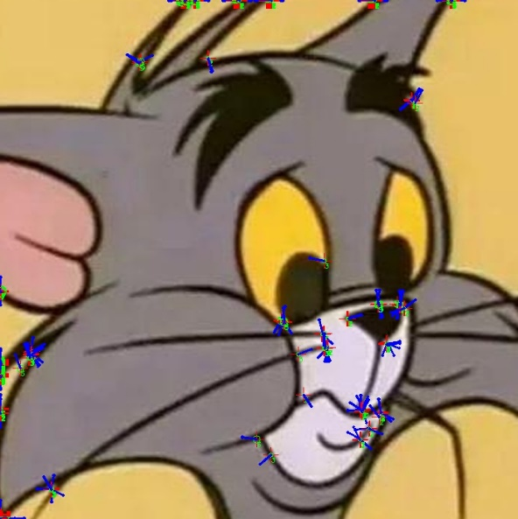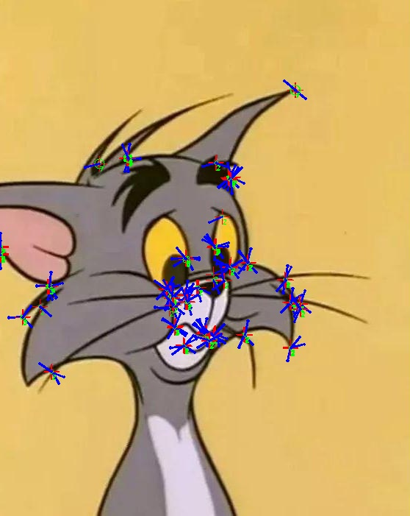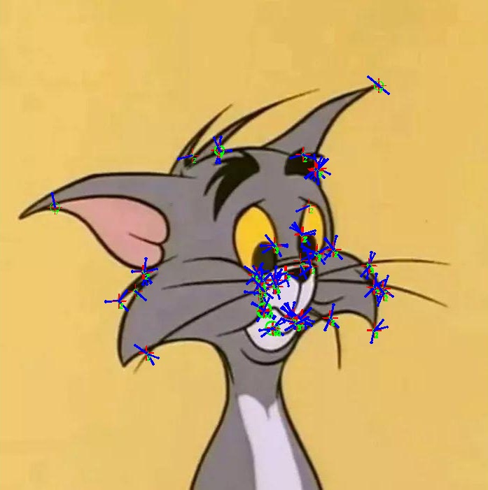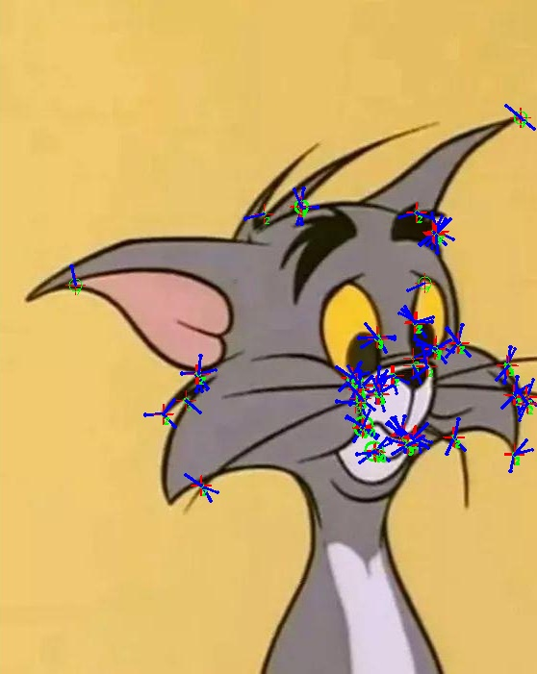

Example 2: runtime：82.23331928253174

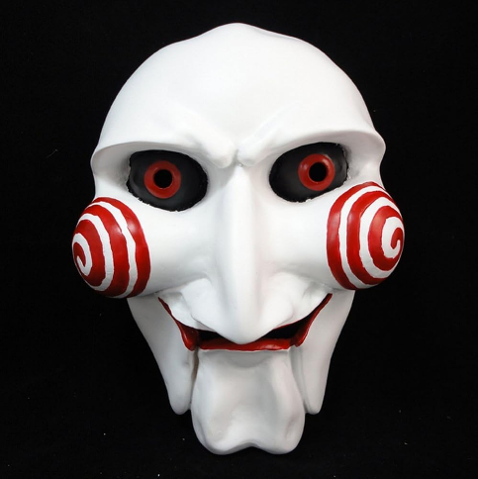

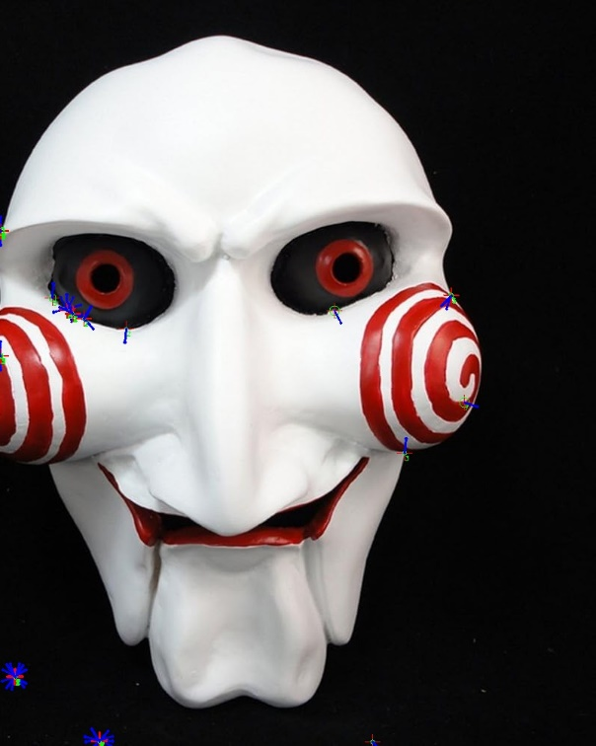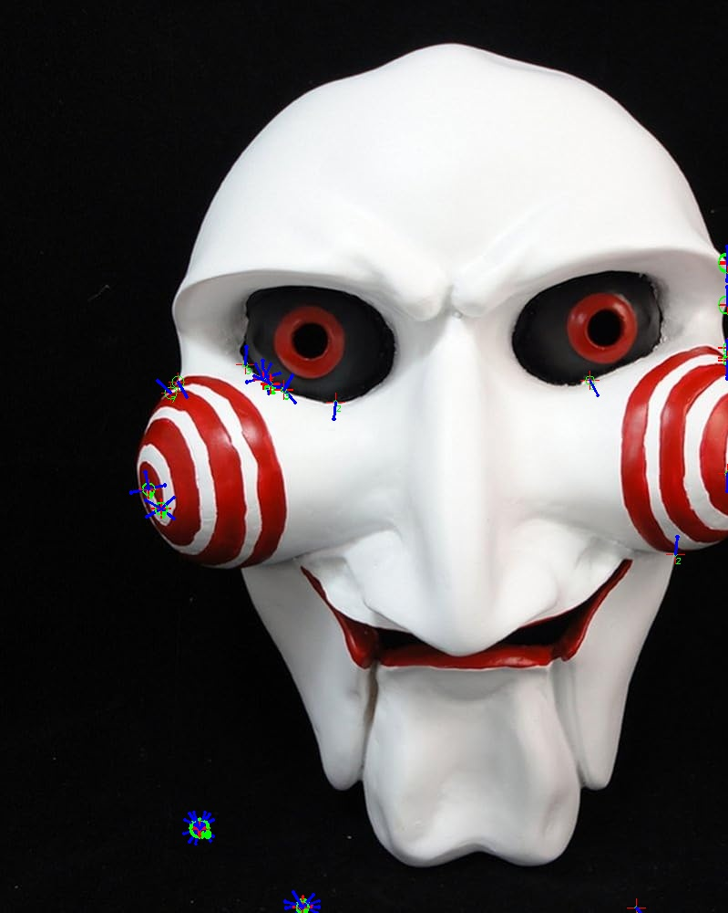

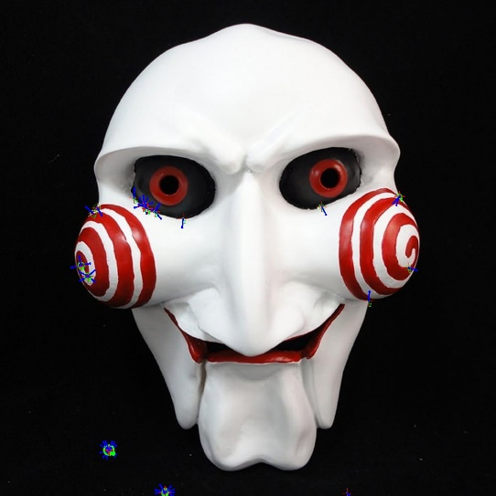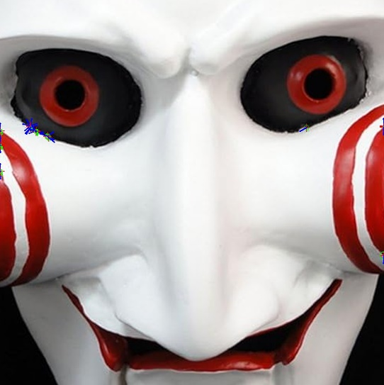

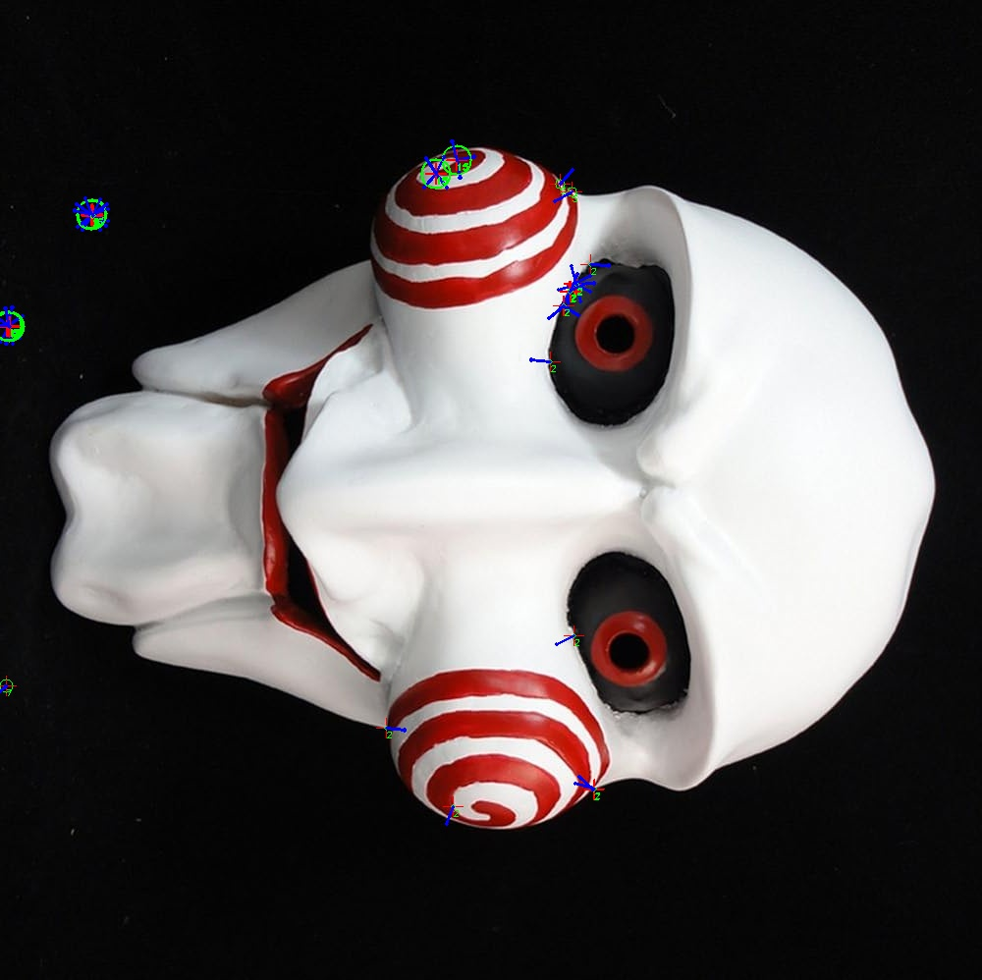

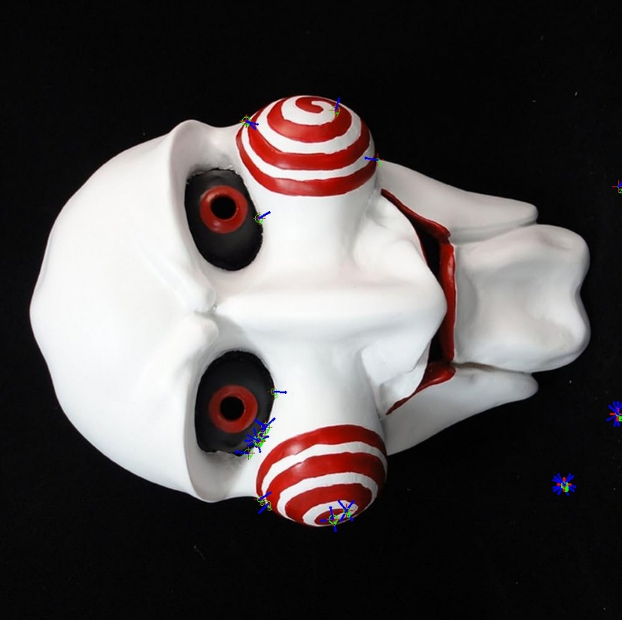

Example 3:runtime: 33.93454909324646

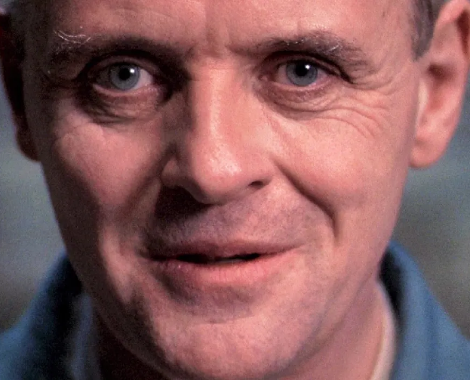

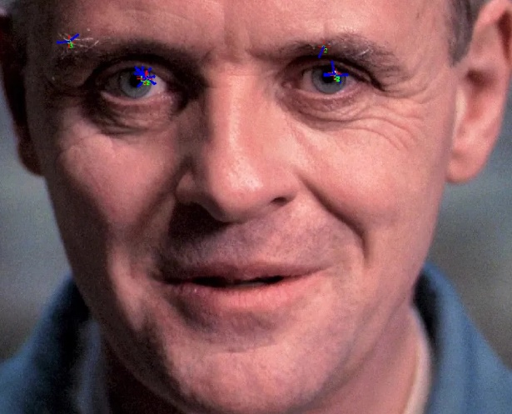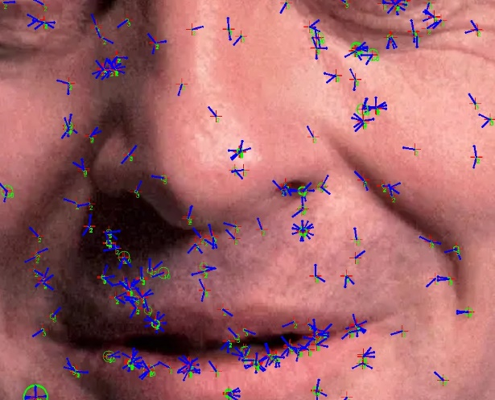

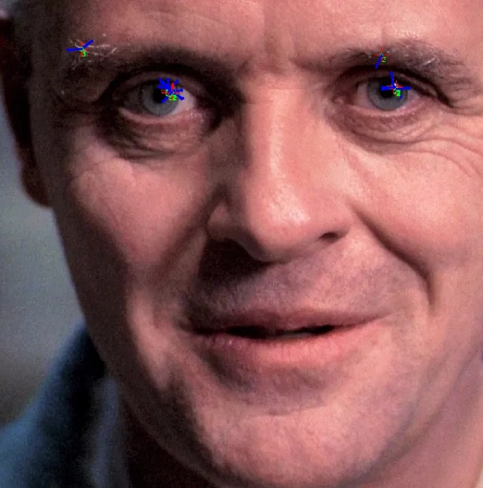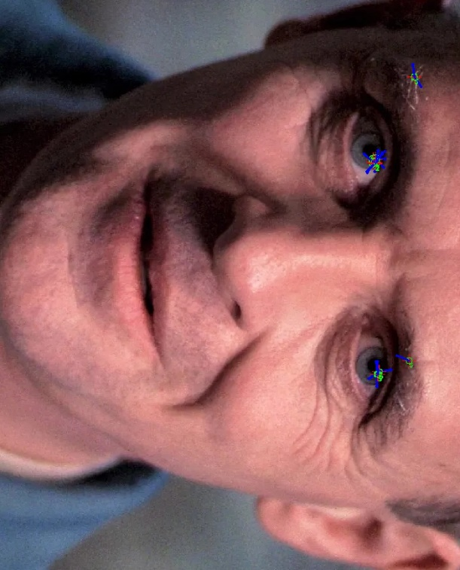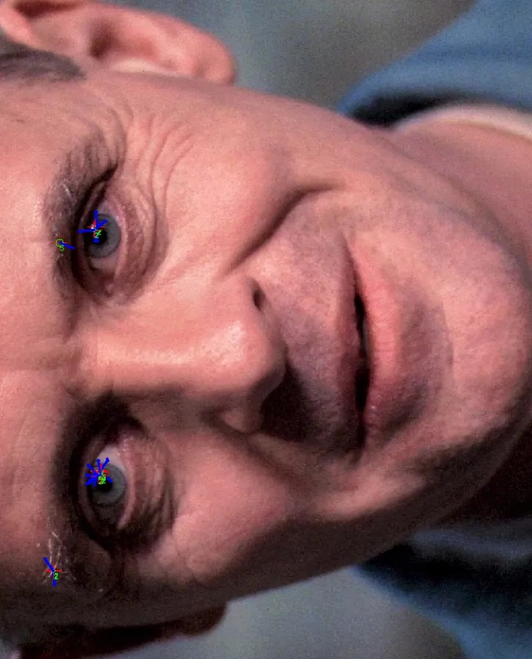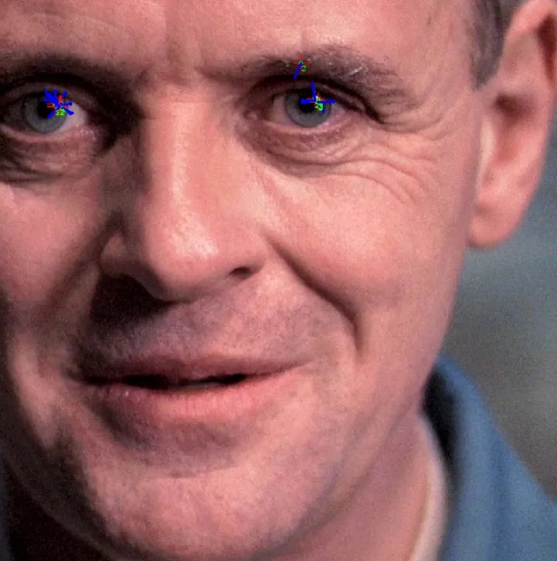

Example 4:runtime: 20.392772436141968

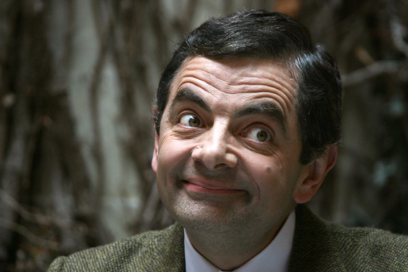

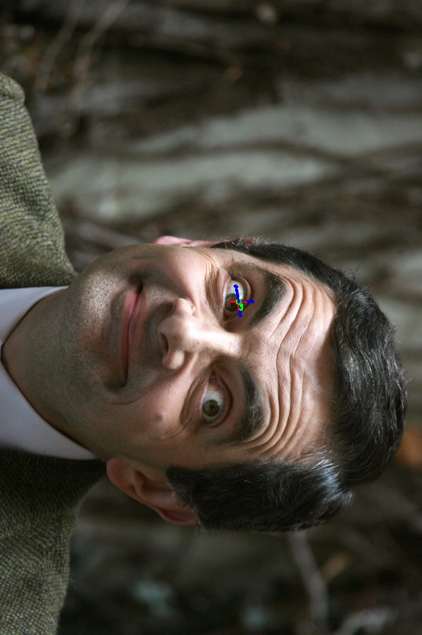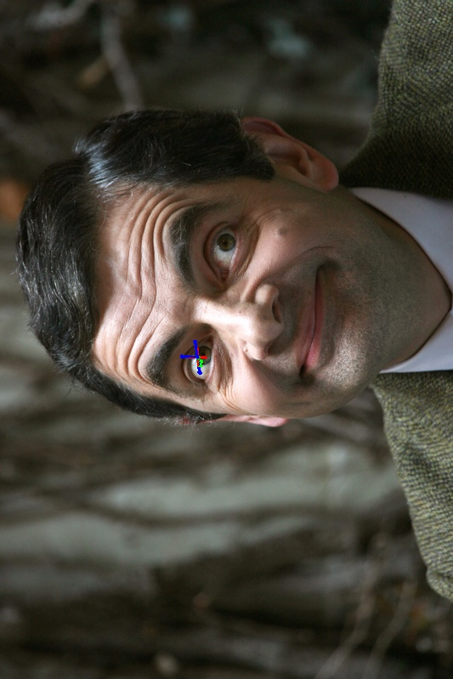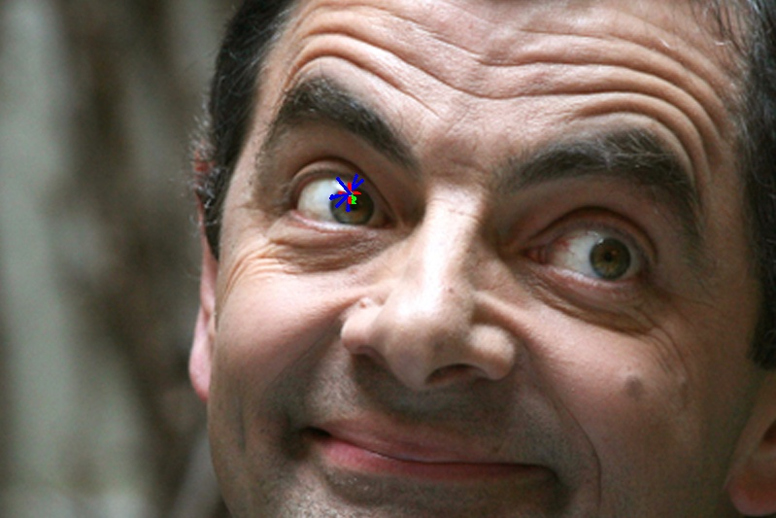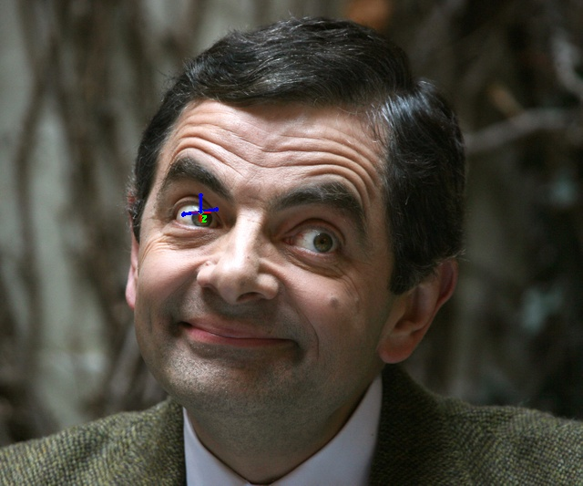

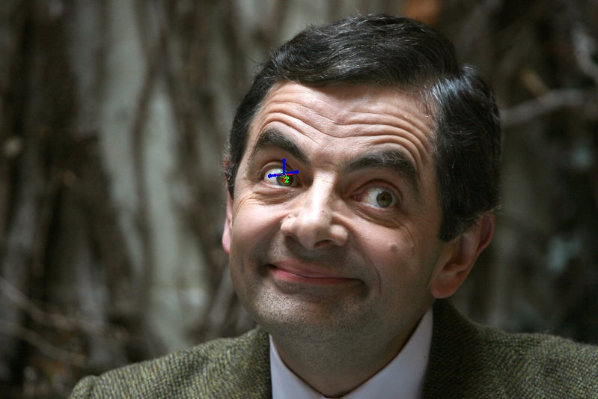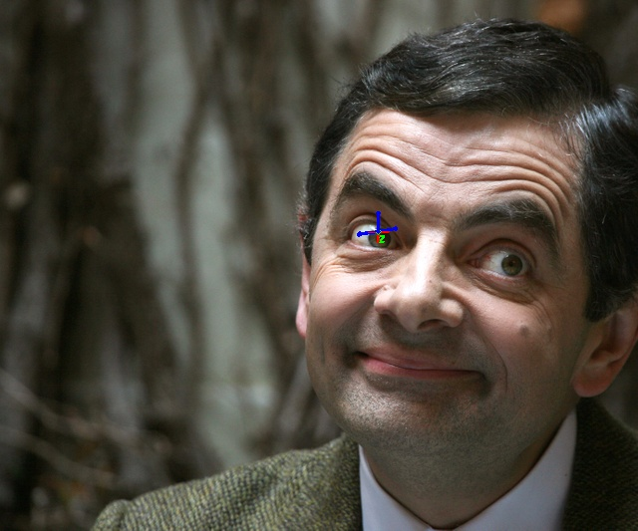

Example 5:runtime: 6.567727088928223

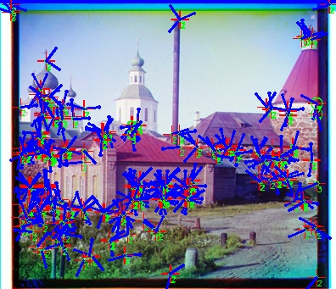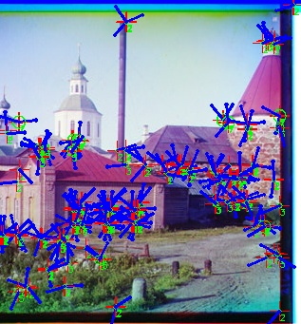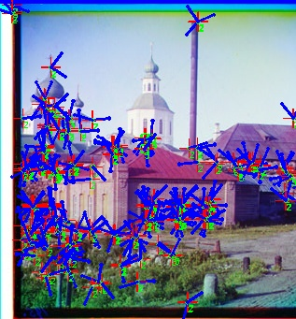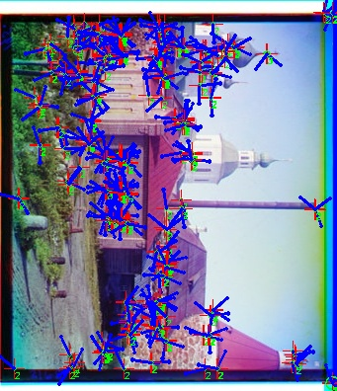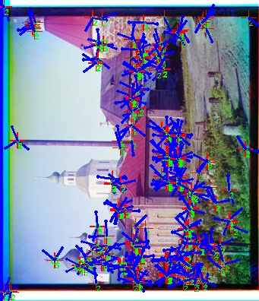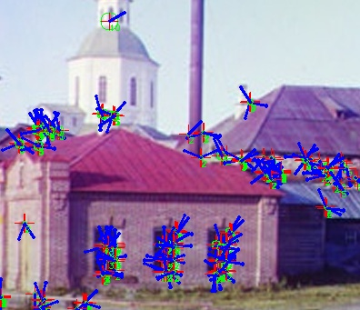

Example 6:runtime: 5.557018995285034

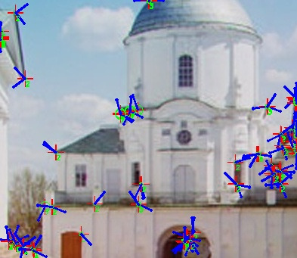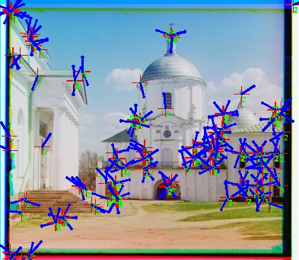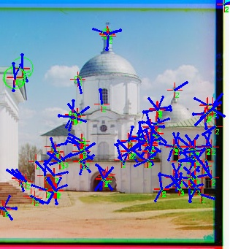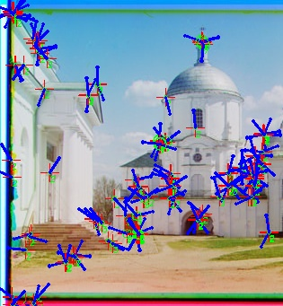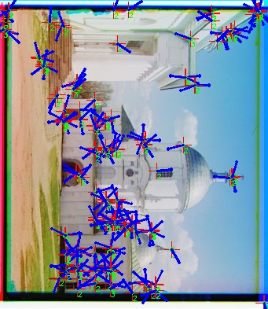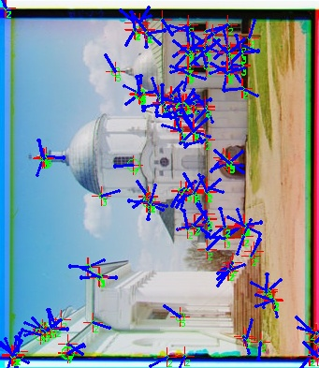

Example 7:runtime: 5.220532178878784

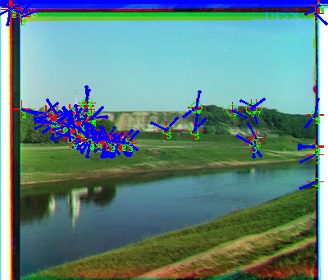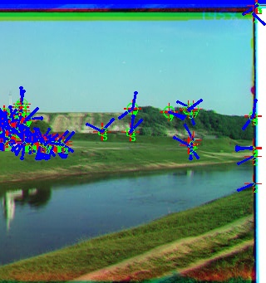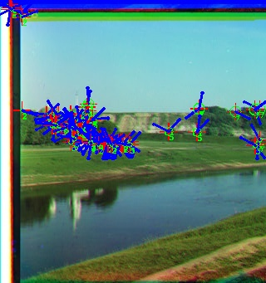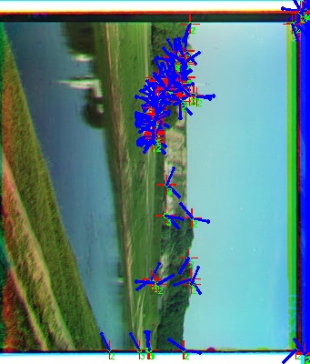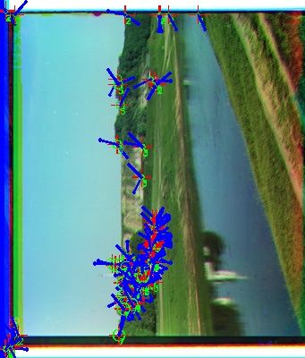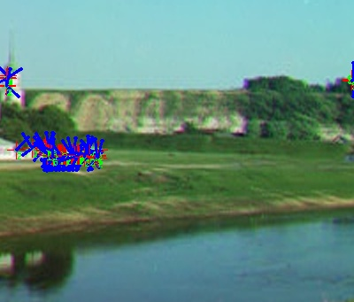

Example 8:runtime: 4.774591445922852

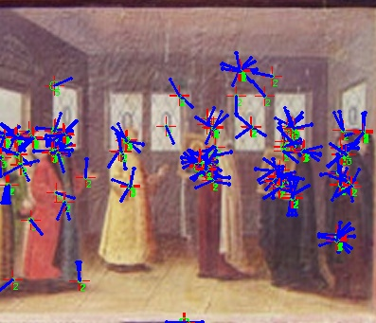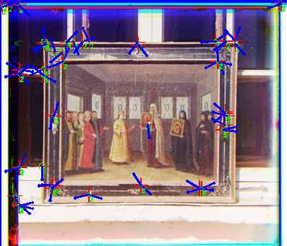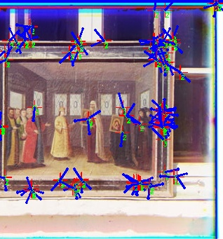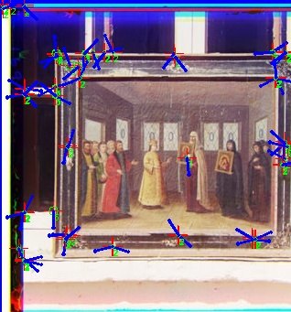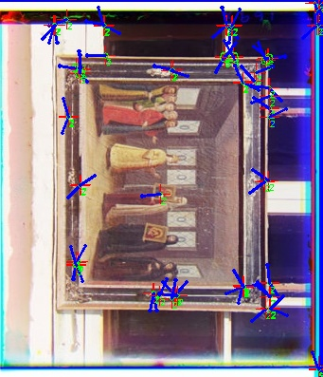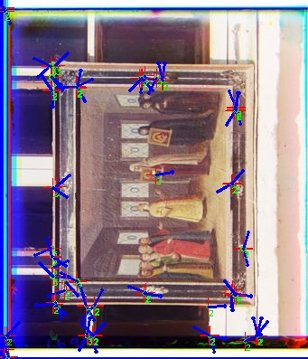

Discussion:

There are five parameters:

init_scale(the first scaling ratio, default is 2),

levels(iteration times, default is 10),

k(the following scaling ratio, default is 1.4),

select_parameter(only preserve corners above a fixed threshold, default is 0.1),

window(window to process the orientation map, default is 10),

I have tried to change the select_parameter to 0.03 and 0.3, and the marks on the output image became less with select_parameter as 0.3 as the condition became harsher.

When I set k to 1.1 or 1.2, it became slower because the image remains large over iterations. However, setting k to 2 or more won’t work, as the width or height may downsample to 0 after 10 iterations.

The window parameter is also important, as too small window size can result in inconsistency of orientations among nearby corners.

Bonus:

Blob-Detection Extra Credit

●  Discussion and results of any extensions or bonus features you have implemented for Blob-Detection

When I tried to directly filter corners and draw arrows according to the orientation matrix, I found nearby points can result in completely different orientations, so I used the corner matrix to create a mask and use the mask to filter the orientation matrix. Then I processed the filtered orientation mask with local average. It turned out that a local area only output one correct orientation.